Recommendation 1
Redirect federal AI infrastructure funding to provinces with more available power capacity
The evidence from Part 1. Our quantitative analysis of 36 countries using the Tortoise/Stanford AI Index (2024) identifies Infrastructure as Canada’s single largest AI competitiveness gap, scoring 5.2 points below its peer average. Canada ranks 29th of 36 in per-capita compute capacity and 27th in absolute compute—the lowest among all G7 nations. As of November 2023, Canada held just 0.7% of global AI compute capacity, half that of the United Kingdom, the next lowest G7 nation (Cassels, 2024). Our Lasso regression (R² = 0.88) confirms Infrastructure is among the strongest predictors of overall AI competitiveness, meaning closing this gap would yield the highest return on investment of any federal intervention. These rankings reflect a broader deficit in physical AI compute infrastructure—data centers, GPU clusters, and national research facilities—the facilities required to house the hardware that delivers compute capacity. Among these, data centers represent the largest category of planned federal investment ($700M via the AI Compute Challenge) and the most acute siting bottleneck, making them the focus of this recommendation.
The problem is not funding—it is allocation. In Budget 2024, the federal government committed $2 billion over five years through the Canadian Sovereign AI Compute Strategy, including $700M via the AI Compute Challenge for private-sector data center construction and up to $300M through the AI Compute Access Fund for SMEs (ISED, 2024). Canada is not short of funding commitments. However, none of these programs include geographic siting criteria. The AI Compute Challenge is awarded competitively based on project proposals, with no conditionality on where projects are located.
The result is severe geographic concentration. Toronto, Montreal, and Alberta collectively account for 93% of Canada’s total data center IT load (DC Byte, 2025). All three markets are now hitting hard grid limits. In Alberta, 29 data center projects representing over 16 GW of demand sought grid connections, but AESO can only accommodate 1.2 GW by 2028; all remaining applications have been paused (AESO, 2025; TD Economics, 2025). In Quebec, Bill 69 (enacted June 2025) requires ministerial authorization for any new load of 5 MW or more (Osler, 2025; Stikeman Elliott, 2025). In Ontario, new data center connection requests already represent approximately 30% of 2024 peak demand, and the government introduced Bill 40 to establish a screening framework for new connections (Osler, 2025). The first major investment under the Strategy—$240M to Toronto-based Cohere—confirmed this pattern (Torys, 2024). Federal dollars intended to close the infrastructure gap are flowing into markets that physically cannot absorb new load.
Meanwhile, provinces with surplus capacity remain untapped. Manitoba’s total generating capacity is approximately 6,100 MW, with 99.7% of electricity from renewable sources. The province generates more electricity than it needs and exports the surplus to the United States, Saskatchewan, and Ontario—export revenues accounted for over 22% of Manitoba Hydro’s total electric revenue from 2010–2019 (Manitoba Hydro; Canada.ca Clean Electricity Snapshot, 2024; CER Provincial Energy Profile, 2024). Manitoba’s export transmission capacity alone reaches 3,185 MW following the 2020 Manitoba-Minnesota Transmission Project (CER, 2024). Newfoundland and Labrador has over 8,000 MW of total generating capacity, anchored by the 5,428 MW Churchill Falls generating station—one of the largest hydroelectric facilities in North America—and is a net electricity exporter (CER, 2024). Saskatchewan is expanding wind capacity with low industrial demand relative to generation. Yet all three provinces have attracted near-zero AI data center investment. This is a policy coordination failure, not a resource constraint.
Geospatial verification. To confirm that surplus-capacity provinces can realistically support data center development, we conducted a suitability analysis using ArcGIS Pro, integrating four data layers: proximity to large-scale power generation (100 MW+ within 100 km, NRCan/NACEI), broadband connectivity (50/10 Mbps+ coverage, CRTC), and low seismic and flood hazard risk (NRCan). The analysis identifies significant suitable areas across the Saskatchewan-Manitoba corridor, Northern Ontario, and Atlantic Canada. This does not prescribe specific sites but demonstrates that provinces with surplus electricity also meet the basic infrastructure requirements for data center development (see Appendix, Figure X).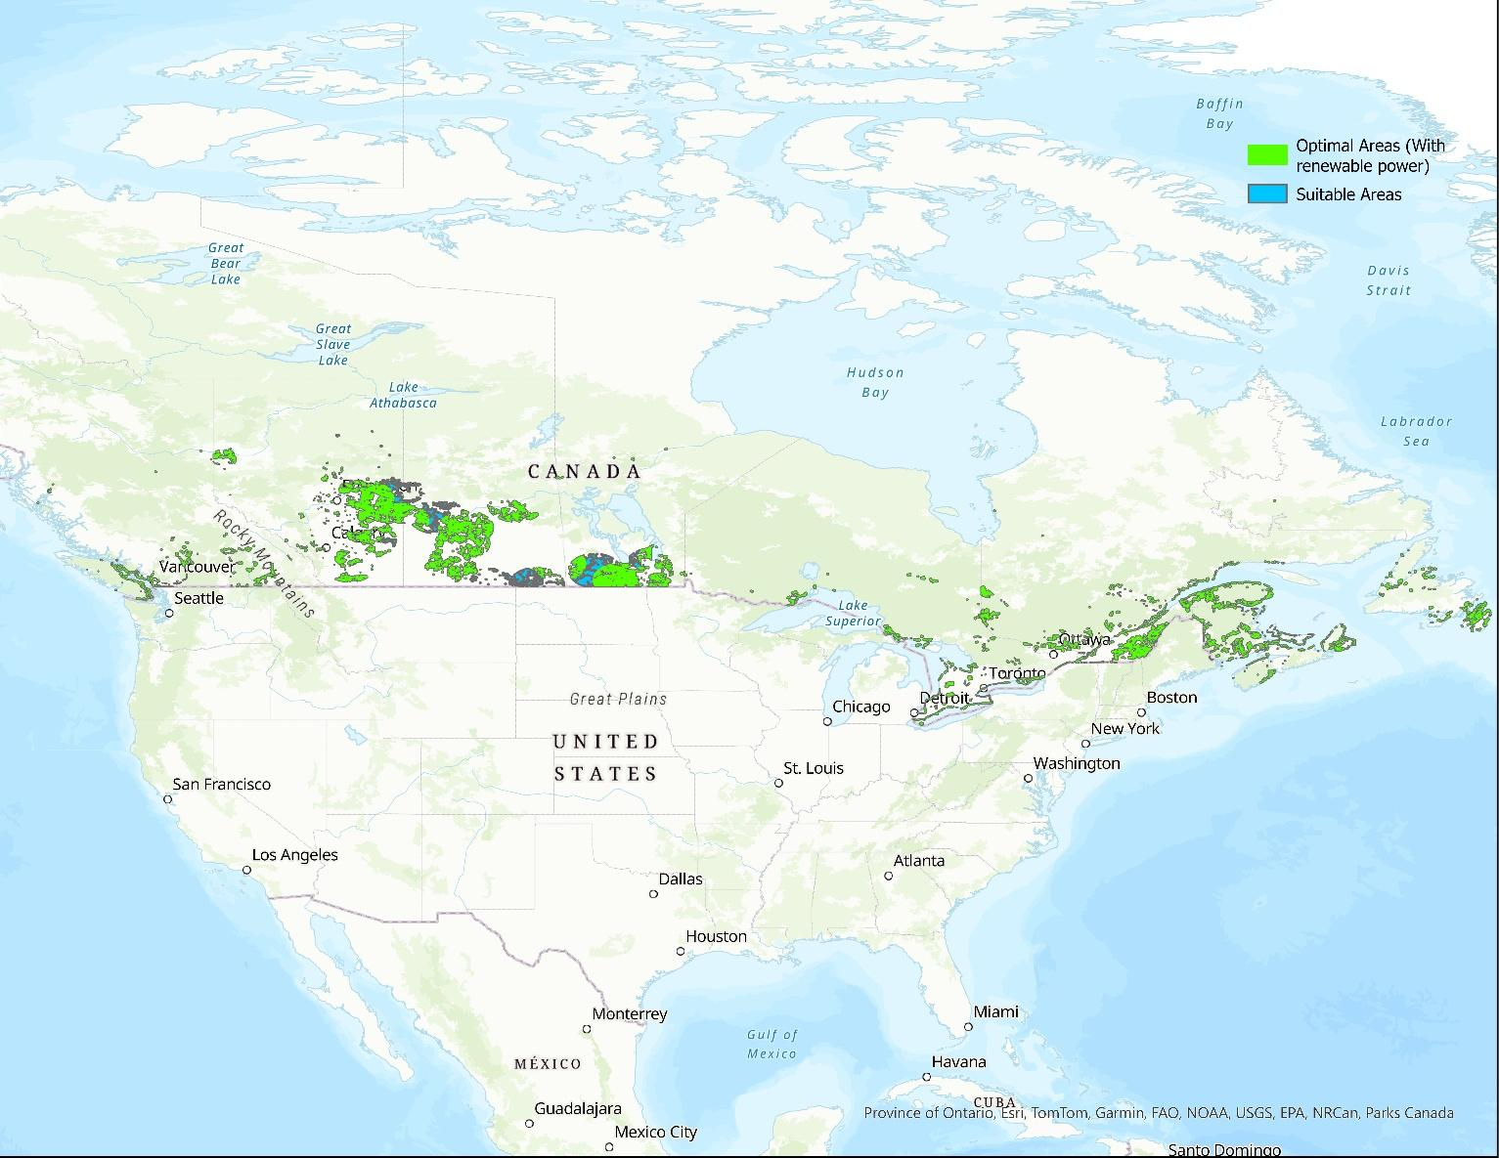
International precedent. Singapore imposed a data center moratorium from 2019 to 2022, then reopened with geographic and sustainability conditionality through the DC-CFA framework (IMDA, 2024). France’s national AI strategy under France 2030 emphasizes territorial distribution of AI infrastructure, with over 30 government-approved low-carbon sites designated across the country to encourage investment beyond Paris (Élysée, 2025). Canada is the only major AI-investing nation directing billions into compute infrastructure with no geographic guidance.
Recommendation. We recommend that ISED introduce geographic conditionality into the $700M AI Compute Challenge, ensuring that a meaningful share of funded capacity is directed toward provinces with demonstrated surplus electricity and available grid connections—specifically Manitoba, Newfoundland and Labrador, and Saskatchewan. This can be achieved through two complementary policy tools. First, amend the AI Compute Challenge evaluation criteria to award significant additional scoring weight to projects located in regions with available grid capacity, verified renewable energy supply, low natural-hazard risk, and no utility-imposed connection moratoriums. Second, extend the Accelerated Investment Incentive (reinstated in the 2024 Fall Economic Statement) to include enhanced capital cost allowance rates for data center equipment deployed in designated surplus-capacity provinces, reducing upfront capital costs and incentivizing private-sector location decisions.
This recommendation does not require the federal government to build data centers, override provincial jurisdiction, or create new spending. It redirects already-committed funding by adding geographic criteria to existing programs—the same approach used successfully by Singapore and France.
Implementation
Responsible agency | ISED, in coordination with NRCan, the Canada Infrastructure Bank, and provincial utilities (Manitoba Hydro, NL Hydro, SaskPower).
Estimated cost | $15–25M for criteria development and inter-agency coordination (<4% of the $700M AI Compute Challenge). Core mechanism is reallocation of existing funding, not new spending.
Timeline | Year 1: Amend AI Compute Challenge scoring criteria; engage provincial utilities on capacity inventory. Year 2: Implement enhanced capital cost allowances for surplus-capacity provinces; publish suitability data as open data. Year 3: Review outcomes; extend conditionality to CIB AI lending.
Success metric | Reduce the share of federally-funded data center capacity in Toronto/Montreal/Alberta from 93% to below 70% within three years. This target is benchmarked against the Netherlands—Canada’s closest KNN peer—where Amsterdam accounts for approximately 70% of national capacity, a level reached only after a 2019 moratorium on new data center development due to grid congestion (DDA, 2025).
Expected Impact：
Closing the infrastructure gap — Canada's single largest AI weakness — would move Canada from 17th toward a projected top-12 composite AI ranking among the 36 countries analyzed in Part 1. Redirecting investment to surplus-capacity provinces would relieve grid pressure on Alberta and Ontario, distribute the economic benefits of data center construction to regions that currently receive none, and convert stranded provincial energy assets into a national competitive advantage: Manitoba and Newfoundland currently export surplus clean electricity to American utilities, while Canada imports the compute capacity that electricity could power domestically.

References
[1] Part 1 Quantitative Analysis — Tortoise/Stanford AI Index 2024, 36 countries, 26 features. MIE 1624 Course Project.
[2] ISED. Canadian Sovereign AI Compute Strategy. December 2024. ised-isde.canada.ca
[3] Department of Finance Canada. 2024 Fall Economic Statement. December 16, 2024. budget.canada.ca
[4] Torys LLP. Catalyzing AI Infrastructure: Opportunities with the Canadian Sovereign AI Compute Strategy. December 2024.
[5] Cassels. Canada’s AI Compute Quest: Powering an AI Enabled Future. December 2024.
[6] DC Byte. Canada Data Centre Market Spotlight. November 2025. dcbyte.com
[7] AESO. Large Load Integration Program — Phase I. June 2025. aeso.ca
[8] TD Economics. Data Centers in a Grid Constrained World: Challenges and Opportunities for Canada. 2025. economics.td.com
[9] Osler, Hoskin & Harcourt LLP. Powering AI: Canada’s Evolving Electricity Grid Connection Policies. December 2025.
[10] Stikeman Elliott. Québec Government Adopts Bill 69. June 2025. stikeman.com
[11] Canada.ca. Manitoba: Clean Electricity Snapshot. November 2024.
[12] Manitoba Hydro. Electricity Exports. hydro.mb.ca
[13] CER. Provincial and Territorial Energy Profiles — Manitoba. 2024. cer-rec.gc.ca
[14] CER. Renewable Energy in Canada — Manitoba. 2024. cer-rec.gc.ca
[15] CER. Provincial and Territorial Energy Profiles — Newfoundland and Labrador. 2024. cer-rec.gc.ca
[16] IMDA. Green Data Centre Roadmap. Singapore, 2024. imda.gov.sg
[17] Élysée. Make France an AI Powerhouse. February 2025. elysee.fr
[18] Dutch Data Center Association. Ten Years of State of the Dutch Data Centers. June 2025. dutchdatacenters.nl

